EFFECTS OF PARTICIPATORY MONITORING AND EVALUATION ON THE SUSTAINABILITY OF ECONOMIC STIMULUS PROGRAM IN THE KENYAN EDUCATION SECTOR: A CASE OF NAIROBI COUNTY, KENYA

Response Rate

|  |  |  |
| --- | --- | --- |
| Questionnaire | Numbers | Percent (%) |
| Questionnaire Sent Out | 132 | 100% |
| Questionnaires Returned | 110 | 83% |
| Complete and Useable Questionnaires | 110 | 83% |

The sample size was made of 132 individuals of which 110 individuals filled and returned the questionnaires for data analyses. The 110 questionnaires received made up 83% of the respondents which were complete and usable. Therefore, the response rate or return rate was 83%. Mugenda et. al (2003) recommended a response rate of above 60% as one sufficient to provide valid and reliable data.

Social Demographics

| **Social Demographics** | Frequency (%) |
| --- | --- |
| Gender |  |
| Female | 54 (49%) |
| Male | 56 (51%) |
| Age |  |
| Below 20 | 16 (15%) |
| 20-29 | 74 (67%) |
| 30-39 | 9 (8.2%) |
| 40-49 | 7 (6.4%) |
| Above 50 years | 4 (3.6%) |
| Education |  |
| Diploma | 40 (36%) |
| Bachelor's Degree | 58 (53%) |
| Master’s degree | 7 (6.4%) |
| PHD | 3 (2.7%) |
| Others | 2 (1.8%) |
| Working |  |
| Less than 1 year | 46 (42%) |
| 2-5 years | 42 (38%) |
| 5-10 years | 8 (7.3%) |
| 10-15 years | 4 (3.6%) |
| 15-20 years | 4 (3.6%) |
| Over 20 | 6 (5.5%) |

## Gender

The respondents’ genders were balanced since there were 56 (51%) male respondents and 54 (49%) female respondents. According to the results there were only 2 more male respondents in the sample size. The difference in genders’ counts was little for any gender bias that could be statistically significant.

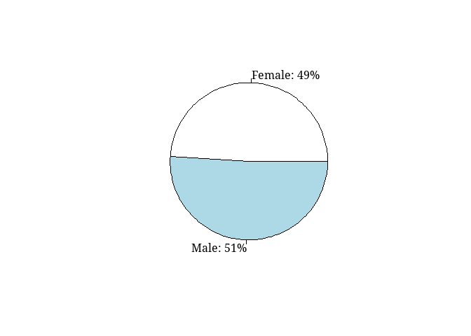

## Age

The majority of the respondents were aged between 20 and 29 years (67%). This meant that most of the respondents included in this study were young people in the study area. In addition, 15% of respondents were under 20 years while only 8%, 6% and 4% of the respondents were between the ages of 30 and 39, 40 and 49 and above 50 years respectively. The results showed that 82% of respondents were under 30 years while 185 were above 30 years old.

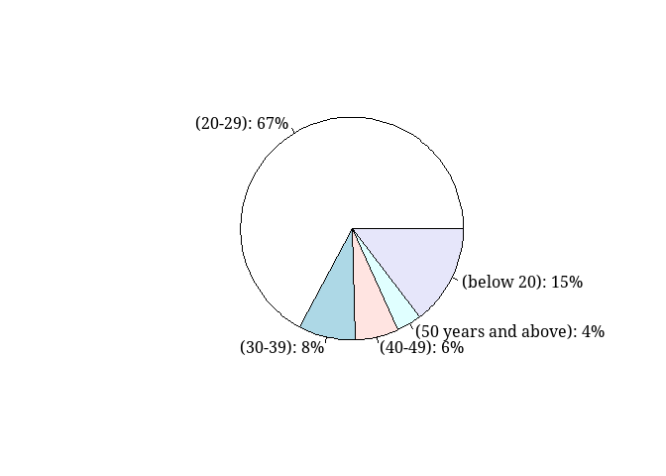

## Education Level

The majority of the respondents had attained a bachelor’s degree (53%), diploma holders were 36% while postgraduates were only 9%. The results indicated the sample size comprised of individuals that were fairly educated since they had a university education or college education only 2% of the respondents reported other forms of education. The implication of the education was that the respondents would be able to provide valuable information as well as provide answers from an intelligent point of view.

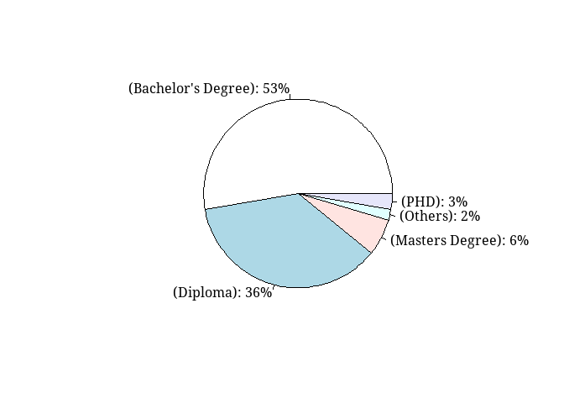

## Working Experience

The earlier results on age reported most of the respondents were under 30 years old, this meant that most of the respondents had not worked for long periods in the Nairobi municipal council. According to the results 42% of the respondents had only worked for less than a year followed by 38% of the respondents that had worked between 2 and 5 years. The lower percentage of respondents had worked longer than 5 years with less 13% having worked for more than 10 years.

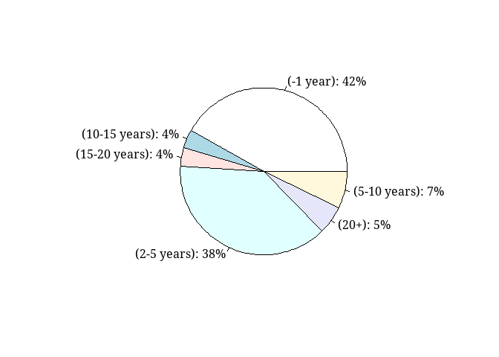

# Stakeholder Involvement

| **Stakeholder Involvement** | **Frequency (%)** |
| --- | --- |
| PME awareness | 53 (48%) |
| PME use frequency |  |
| As per project requirement | 24 (22%) |
| Monthly | 29 (26%) |
| Quarterly | 47 (43%) |
| Yearly | 10 (9.1%) |
| PME interactions |  |
| boring but varied | 7 (6.4%) |
| not sure | 32 (29%) |
| Routine and boring | 13 (12%) |
| Routine but very challenging | 19 (17%) |
| Varied and challenging | 39 (35%) |

## PME Awareness

The respondents were asked whether they were aware of any participatory monitoring and evaluation systems in Nairobi city where only 48% of respondents reported awareness. More than half of the respondents in this study were not aware of the existence of any current systems of participatory monitoring and evaluation. The lack of awareness could be attributable to a few working years and little experience working and living in the city. The results could mean that only a few workers are involved in the PME systems in Nairobi city projects or the possibility that there are no PME systems in place in Nairobi city.

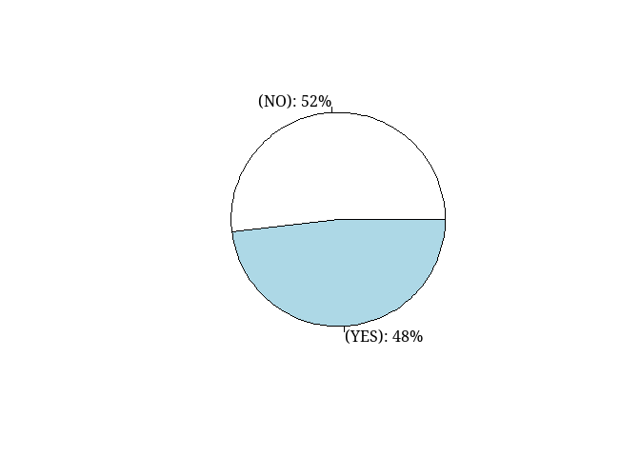

## PME Awareness barplot

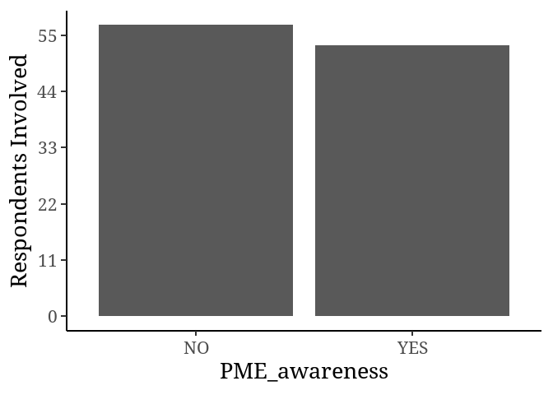

## PME Frequency Use

Participatory monitoring and evaluation were reported by 43% of the respondents as being used quarterly in project management in Nairobi city. Thus, the highest frequency of use of PME system is quarterly followed by monthly and thirdly as per project requirement while 9% of the respondents reported the use PME systems yearly in project management.

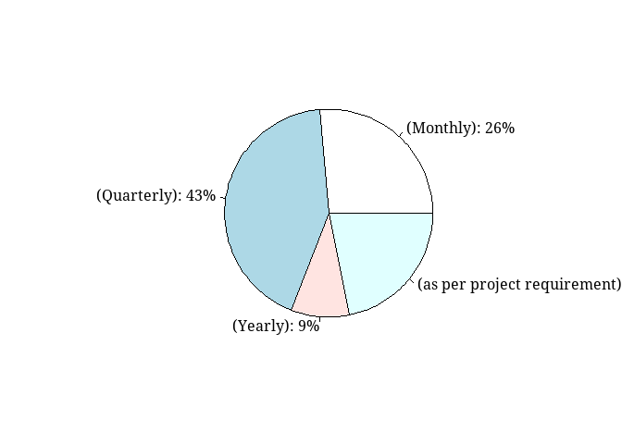

## PME Frequency use bar plot

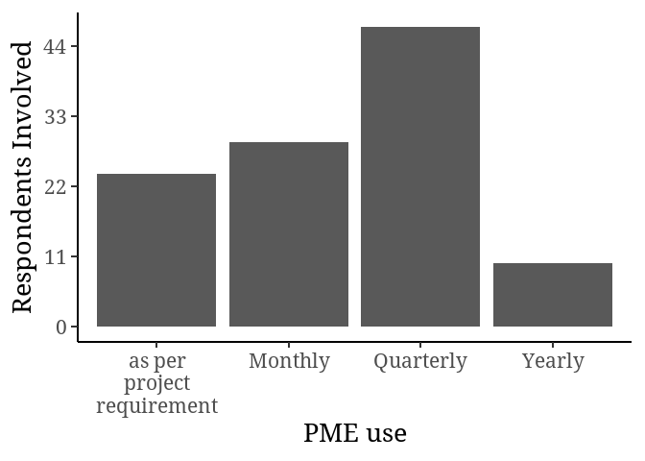

## PME interaction

The interaction with participatory monitoring and evaluation was reported to be varied and challenging among 35% of the respondents while 29% of the respondents were not sure of their interaction with PME systems at work. The PME systems were reported as routine and challenging by 17% of the respondents while 12% found the systems routine and boring while only 6% found the systems boring but varied. The results, therefore, indicated a degree of routine and diversity of the participatory monitoring and evaluation of Nairobi city projects in their management.

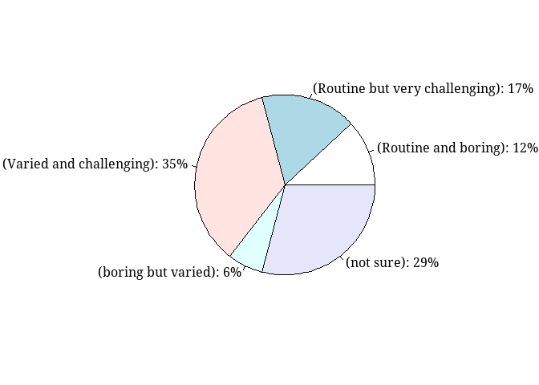

## PME use bar plot.

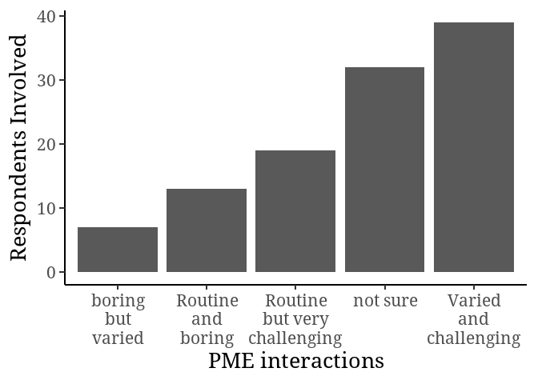

# Key indicators of Stakeholder Involvement

## Categorical wise

| **Key Indicators** | **Strongly agree** | **Agree** | **Neutral** | **Disagree** | **Strongly disagree** | **mean** | σ |  |
| --- | --- | --- | --- | --- | --- | --- | --- | --- |
| Citizen control | 37 (34%) | 36 (33%) | 31 (28%) | 5 (4.5%) | 1 (0.9%) | 3.94 | 0.94 | High Perception |
| Project Identification | 25 (23%) | 54 (49%) | 23 (21%) | 7 (6.4%) | 1 (0.9%) | 3.85 | 0.98 | High Perception |
| Delegation of duties | 27 (25%) | 42 (38%) | 33 (30%) | 7 (6.4%) | 1 (0.9%) | 2.96 | 1.23 | Low Perception |
| Partnership | 27 (25%) | 41 (37%) | 32 (29%) | 5 (4.5%) | 5 (4.5%) | 3.80 | 0.92 | High Perception |
| Project implementation | 32 (29%) | 40 (36%) | 29 (26%) | 7 (6.4%) | 2 (1.8%) | 3.81 | 1.02 | High Perception |
| Project ownership | 37 (34%) | 39 (35%) | 21 (19%) | 10 (9.1%) | 3 (2.7%) | 3.88 | 1.06 | High Perception |
| Project sustainability | 31 (28%) | 40 (36%) | 30 (27%) | 5 (4.5%) | 4 (3.6%) | 3.73 | 1.03 | High Perception |
| Regular Debriefing | 34 (31%) | 32 (29%) | 32 (29%) | 8 (7.3%) | 4 (3.6%) | 3.76 | 1.08 | High Perception |
| Grand Mean (Weighted mean) | | | | | | 3.72 |  |  |

Note: Strongly agree = 5, Agree = 4, Neutral = 3, Disagree = 2, Strongly disagree = 1. Decision; Weighted average = 3.72

According to the results illustrated in the table above majority of the respondents perceived citizen control as a key involvement indicator of participatory monitoring and evaluation programs in Nairobi. Majority of respondents were also in agreement with the statement that involvement in the project identification stage largely contributed to the participatory monitoring and evaluation of projects within Nairobi County. Delegation of duties was not a key indicator of stakeholder involvement according to majority of the respondents. The respondents felt that just delegation of duties did not contribute to stakeholder involvement in participatory monitoring and evaluation systems. Majority of respondents perceived partnerships as key indicators of involvement in participatory monitoring and evaluation systems. The involvement of respondents in the project implementation stage was perceived by most respondents as a key indicator of stakeholder involvement in participatory monitoring and evaluation in project management programs. Project ownership was perceived my majority of respondents as a key indicator of stakeholder involvement. The sustainability of projects within Nairobi County was perceived to be as a result of stakeholder’s involvement in the participatory monitoring and evaluation systems and thus a key indicator of stakeholder engagement. Holding of regular briefs to the stakeholders regarding government projects was perceived as a key indicator of stakeholder involvement in Nairobi County project programs. The results, therefore, indicated that partnerships, sustainability regular briefs regarding projects, and involvement of stakeholders in project identification and implementation were identified as a key indicators of stakeholder involvement within the participatory monitoring and evaluation system within Nairobi County.

## Capacity building

| **Capacity Building** | **Strongly agree** | **Agree** | **Neutral** | **Disagree** | **Strongly disagree** | **mean** | σ | **decision** |
| --- | --- | --- | --- | --- | --- | --- | --- | --- |
| Capacity building of stakeholders is one of the intermediate results of PM&E of economic stimulus program’s sustainability in the education sector at Nairobi County | 52 (47%) | 36 (33%) | 19 (17%) | 1 (0.9%) | 2 (1.8%) | 2.33 | 1.37 | Not in  agreement |
| Capacity building of stakeholders has a relationship with the sustainability of economic stimulus program in the education sector at Nairobi County | 35 (32%) | 35 (32%) | 34 (31%) | 4 (3.6%) | 2 (1.8%) | 3.88 | 0.96 | In agreement |
| Illiteracy is a key hindrance to Participatory Monitoring and Evaluation of economic stimulus program’s sustainability in the education sector at Nairobi County | 39 (35%) | 29 (26%) | 32 (29%) | 7 (6.4%) | 3 (2.7%) | 3.85 | 1.07 | In agreement |
| Grand Mean (Weighted mean) | | | | | | 3.35 |  |  |

Note: Strongly agree = 5, Agree = 4, Neutral = 3, Disagree = 2, Strongly disagree = 1. Decision; Weighted average = 3.35

Majority of the respondents did not believe that capacity building of stakeholders is one of the intermediate results of PM&E of economic stimulus program’s sustainability in the education sector at Nairobi County, however majority of the respondents felt that capacity building of stakeholders had a relationship with the sustainability of economic stimulus program in the education sector at Nairobi County while the majority also agreed that illiteracy was a key hindrance to Participatory Monitoring and Evaluation of economic stimulus program’s sustainability in the education sector at Nairobi County. The respondents were therefore found to be agreement with the principle of success of projects due to capacity building of stakeholders by identifying illiteracy as a hinderance to sustainability of Nairobi County programs within the education sector.

## Stakeholder ownership

| Stakeholder Ownership | **Strongly agree** | **Agree** | **Neutral** | **Disagree** | **Strongly disagree** | **mean** | σ | **decision** |
| --- | --- | --- | --- | --- | --- | --- | --- | --- |
| PM&E strengthens ownership of economic stimulus program’s sustainability in the education sector | 45 (41%) | 37 (34%) | 27 (25%) | 0 (0%) | 1 (0.9%) | 3.65 | 1.61 | Not in agreement |
| PM&E allows for those directly affected to draw both successes and failures since it puts them in charge | 23 (21%) | 54 (49%) | 29 (26%) | 2 (1.8%) | 2 (1.8%) | 3.85 | 0.83 | In agreement |
| Meaningful and greater participation allows stakeholders to influence decision-making, resource allocation, implementation, and control of development initiatives | 33 (30%) | 38 (35%) | 25 (23%) | 12 (11%) | 2 (1.8%) | 3.8 | 1.05 | In agreement |
| Stakeholder’s support of the projects strengthens sustainability of economic stimulus programs in the education sector | 31 (28%) | 36 (33%) | 35 (32%) | 3 (2.7%) | 5 (4.5%) | 3.77 | 1.04 | In agreement |
| Grand Mean (Weighted mean) | | | | | | 3.77 |  |  |

Note: Strongly agree = 5, Agree = 4, Neutral = 3, Disagree = 2, Strongly disagree = 1. Decision; Weighted average = 3.77

The majority of respondents did not feel that PM&E strengthened ownership of economic stimulus program’s sustainability in the education sector. However, majority of respondents agreed that PM&E allowed for those directly affected to draw both successes and failures since it put them in charge and that meaningful and greater participation allowed stakeholders to influence decision-making, resource allocation, implementation, and control of development initiatives a majority of respondents felt that stakeholder’s support of the projects strengthened sustainability of economic stimulus programs in the education sector. Therefore, according to most respondents PM&E was a useful tool for sustainability and participation in government projects although most respondents did not feel that they owned the projects as individuals.

## Policy recommendation

## Categorical wise

| **Policy recommendation** | **Strongly agree** | **Agree**, N | **Neutral** | **Disagree** | **Strongly disagree** | **mean** | σ | **Decision** |
| --- | --- | --- | --- | --- | --- | --- | --- | --- |
| Government policies determine which appropriate PM&E policies to be adopted on economic stimulus program’s sustainability in the education sector at Nairobi County | 39 (35%) | 33 (30%) | 31 (28%) | 3 (2.7%) | 4 (3.6%) | 3.91 | 1.04 | In Agreement |
| PM&E policies should be accurate, realistic, feasible and reliable in ensuring timely decision making in line with delivery of public education services | 40 (36%) | 29 (26%) | 35 (32%) | 1 (0.9%) | 5 (4.5%) | 3.89 | 1.06 | In Agreement |
| Improved school learning environment as a result of economic stimulus program’s sustainability in the education sector | 36 (33%) | 33 (30%) | 32 (29%) | 4 (3.6%) | 5 (4.5%) | 3.83 | 1.07 | Not In Agreement |
| Grand Mean (Weighted mean) | | | | | | 3.88 |  |  |

Note: Strongly agree = 5, Agree = 4, Neutral = 3, Disagree = 2, Strongly disagree = 1. Decision; Weighted average = 3.88

Majority of respondents felt that Government policies determined the appropriate PM&E policies to be adopted on economic stimulus program’s sustainability in the education sector at Nairobi County and that PM&E policies ought to be accurate, realistic, feasible and reliable in ensuring timely decision making in line with delivery of public education services while did not feel that improved school learning environment is as a result of economic stimulus program’s sustainability in the education sector.